University Of Engineering and Technology, Lahore
Computer Engineering Department

Course Name: PF | Course Code: CMPE-112L
Assignment Type: LAB | Dated: 27 April 2026
Semester: 1st | Session: 2026 Spring
Lab/Project/Assignment #: 7 | CLOs to be covered: CLO3
Lab Title: List and Tuples | Teacher Name: Hafiz Muhammad Mubashar
Lab Evaluation:

CLO1 | Apply appropriate programming techniques to create executable programs to solve well defined problems
 | Level1 | Level2 | Level3 | Level4 | Level5 | Level6
(5)
Total |  |  |  |  |  | /5
Rubrics for Current Lab Evaluation
Scale | Marks | Level | Rubric
Excellent | 5 | L1 | Submitted all lab tasks, BONUS task, have good understanding.
Very Good | 4 | L2 | Submitted the lab tasks but have good understanding
Good | 3 | L3 | Submitted the lab tasks but have weak understanding.
Basic | 2 | L4 | Submitted the lab tasks but have no understanding.
Barely Acceptable | 1 | L5 | Submitted only one lab task.
Not Acceptable | 0 | L6 | Did not attempt
LAB No 7
Lab Goals/Objectives:
- Understand the concept of Lists and Tuples in Python.
- Learn how to store and organize multiple values in collections.
- Create programs using list and tuple operations.
- Understand accessing, updating, and managing collection data.

Equipment Required:
- Computer/Laptop
- Python IDE
- Python Interpreter

Theory:
A List in Python is an ordered collection of elements that is mutable, meaning values can be added, removed, or changed after creation. Lists are useful for storing and managing multiple items.

A Tuple in Python is an ordered collection of elements that is immutable, meaning its values cannot be changed after creation. Tuples are useful for storing fixed data securely.

The collection contains:
- Elements stored in sequence
- Indexing for accessing data
- Methods and operations for managing values

Lab Work:

Task 1:
Create a list containing mixed data types (integer, string, and number). Add an element to the end of the list and print the updated list.

Result:

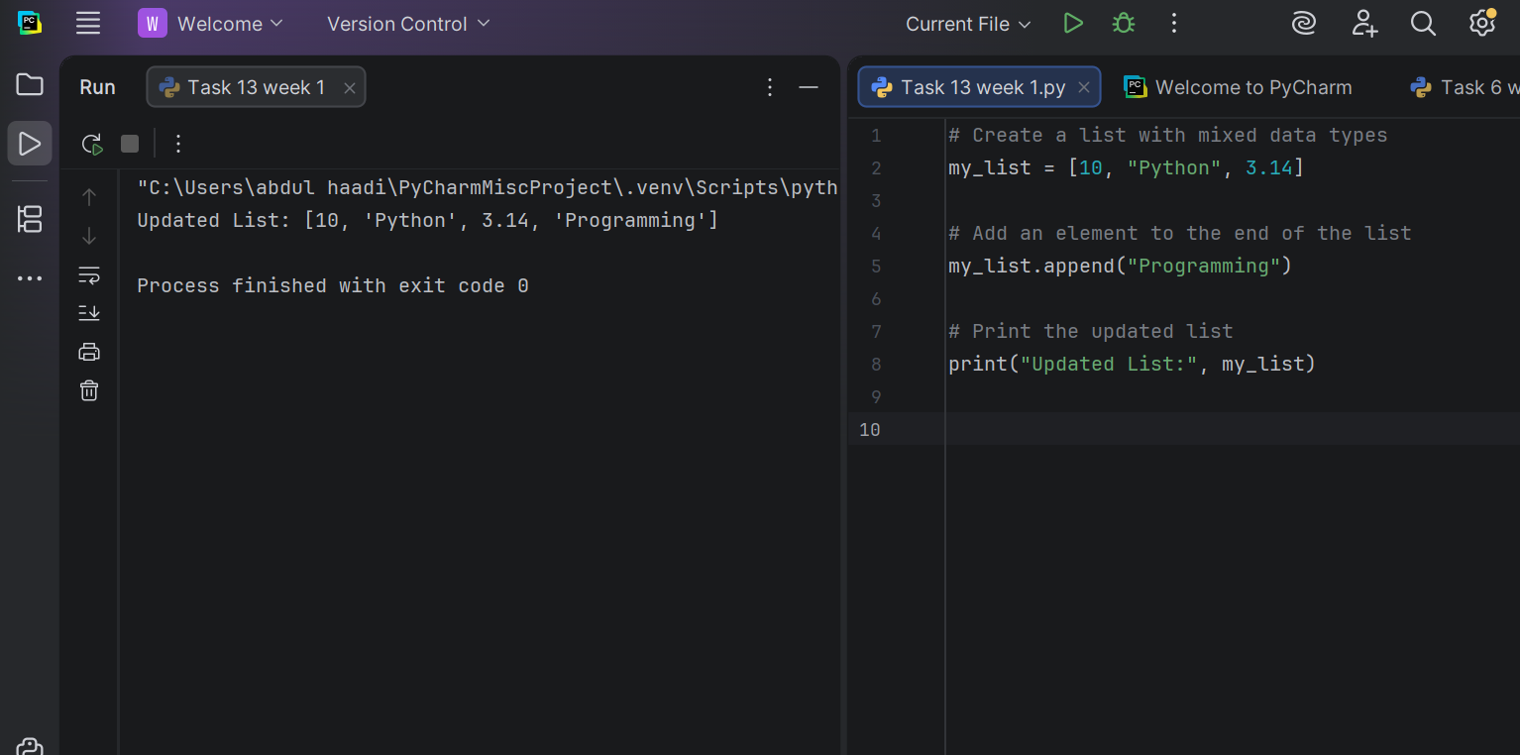 Task 2:
Create a list of fruits (apple, banana, mango) and print the entire list.

Result:
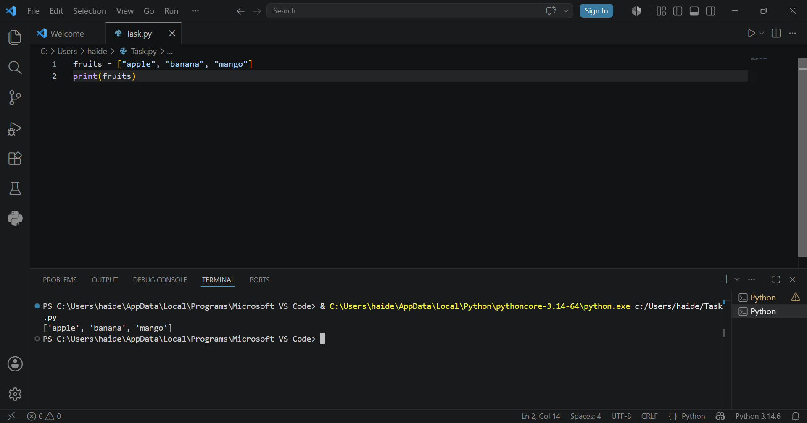

Task 3:
Write a Python program that creates a list of numbers containing 10, 20, 30, 40, and 50. The program should use built-in functions to find and display the largest number, the smallest number, and the sum of all the numbers in the list.

Result: 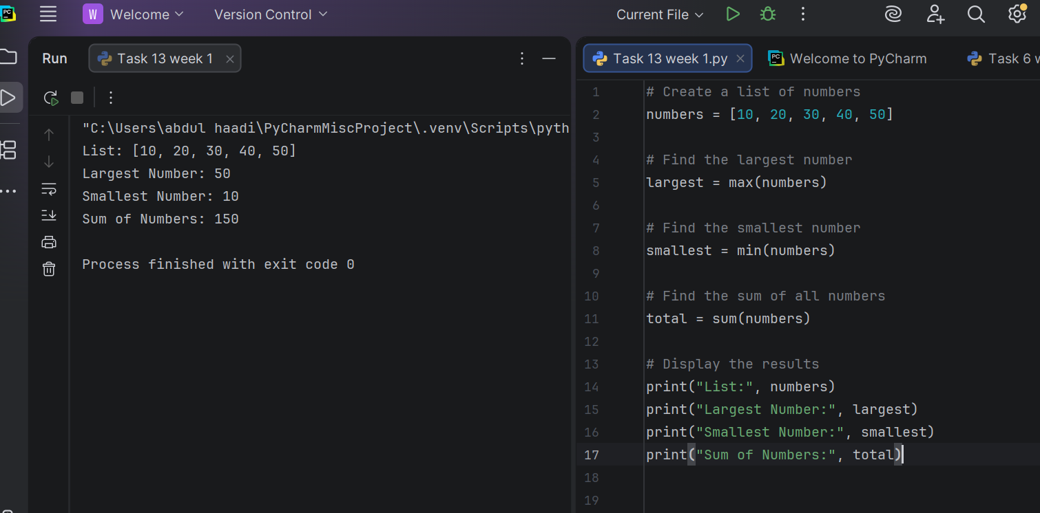
Task 4:
Create a tuple containing three fruit names and print the tuple.

Result:
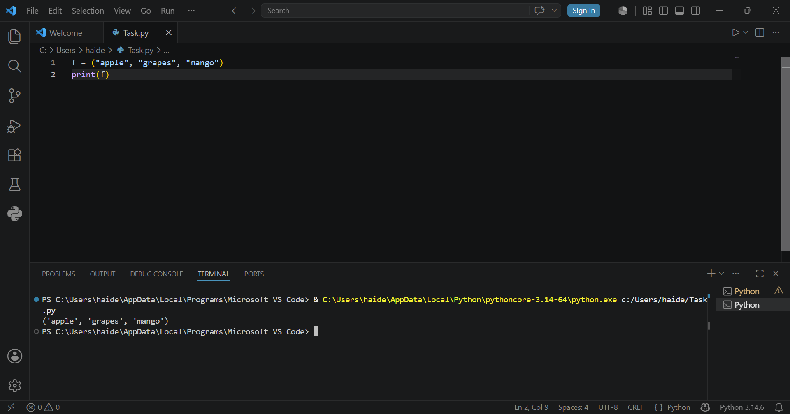

Task 5:
Create a tuple with mixed data types. Try to append an element to it and observe the error. (Note:
This will generate an AttributeError)
Result: 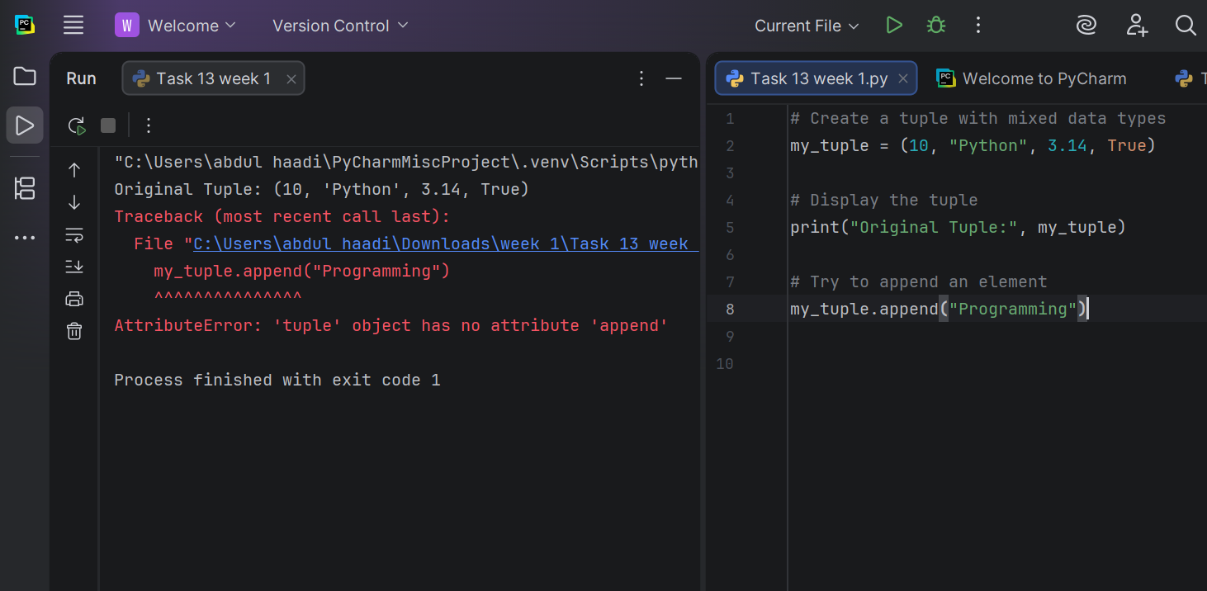

Task 6:
Create a tuple of fruits. Try to change the first element to "grape" and observe the error. (Note: This
will generate a TypeError)

Result:

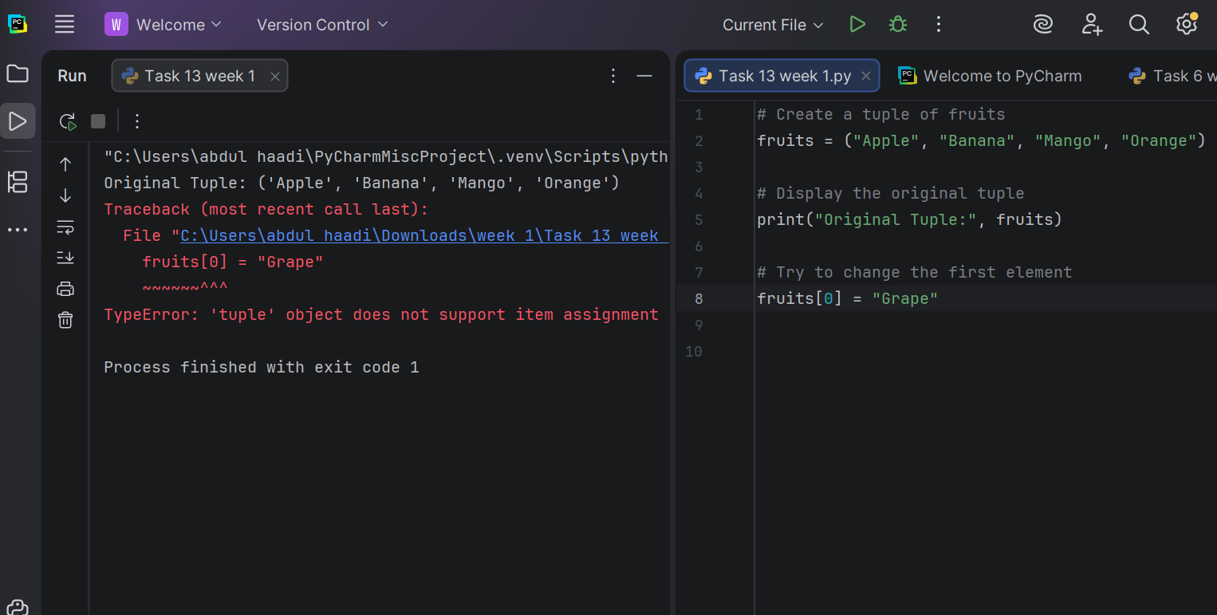

Task 7:
Create a tuple with three numbers and print its type using the type() function.

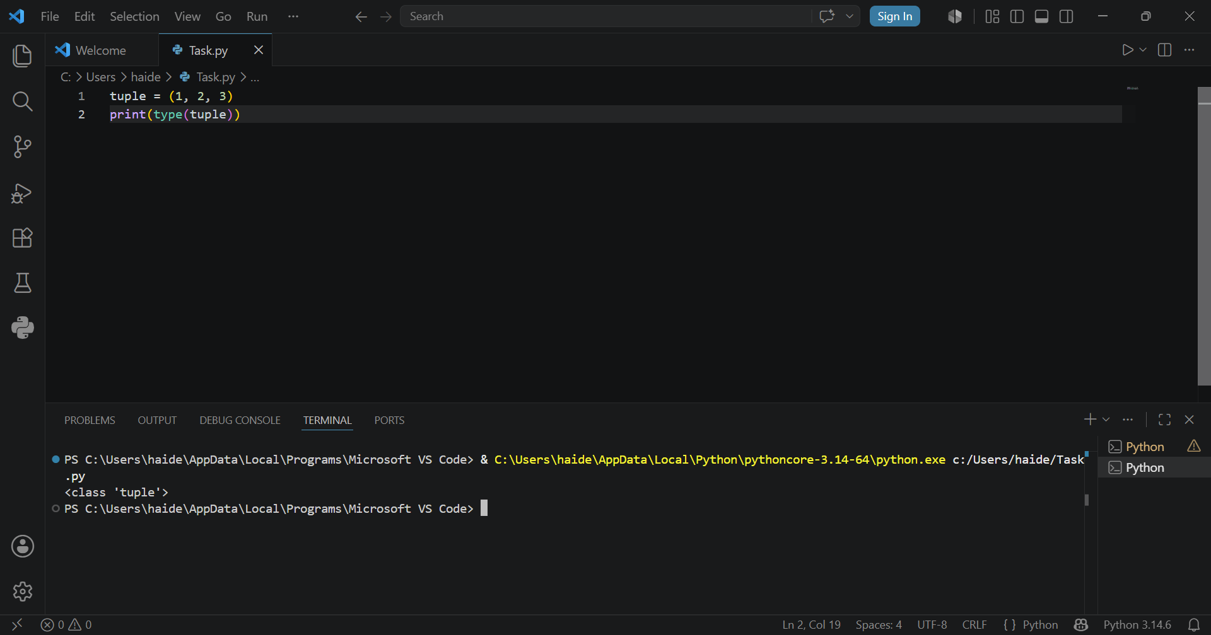
Result:
Conclusion:
Lists and tuples are both fundamental data structures in Python used to store collections of items, but they have a crucial difference: mutability. Lists are mutable, meaning their elements can be changed, added, or removed after creation, as demonstrated when we appended an element to a list. Tuples, on the other hand, are immutable – once created, their elements cannot be modified, added, or removed. This immutability was clearly shown when we tried to append to a tuple (getting an AttributeError) and when we attempted to change an element (getting a TypeError). Both structures can store mixed data types (integers, strings, etc.) and are accessed using indexing. While lists are more flexible and commonly used for dynamic data, tuples are preferred for fixed data that shouldn't change, offering better performance and serving as dictionary keys. Understanding when to use each is essential for writing efficient and bug-free Python code!

Result:

